Author: Jacqueline Allan
DWED/Birkbeck
Focus on Nutrition
December 2017
*Graphic from DrAxe.com
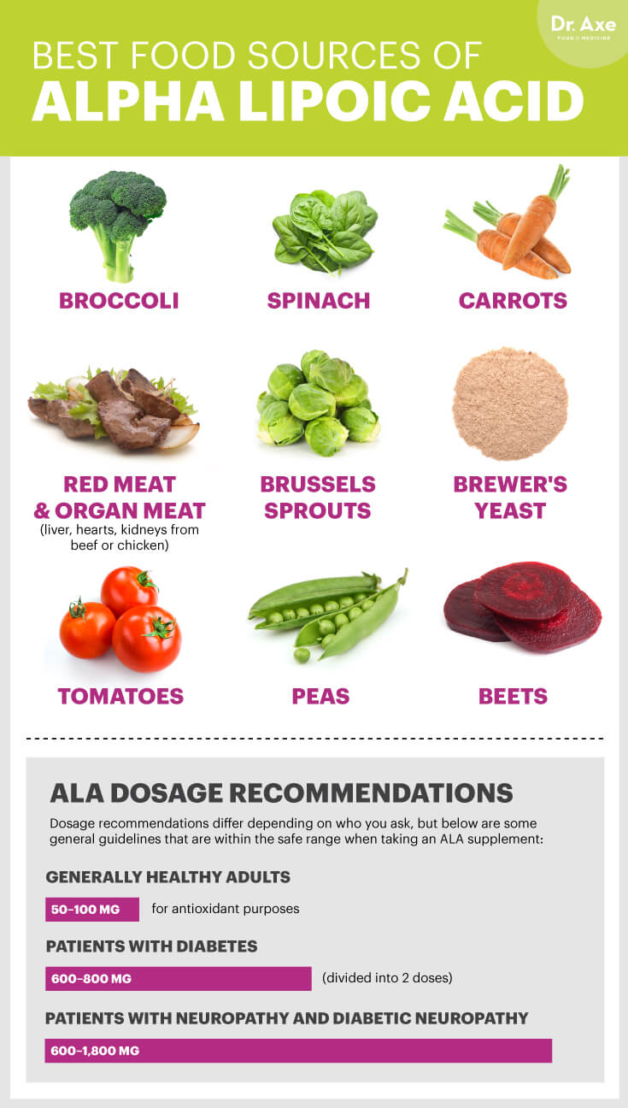
[Document title]
[Document subtitle]

Focus on Nutrition: Alpha Lipoic Acid
What is it? ALA is an important component in the process that converts glucose into usable energy. The conversion process that transfers food into energy creates ‘free radicals’ which harm may harm cells. ALA is also an antioxidant which means that it attacks these substances. It may also increase levels of other antioxidants in the cells.
What does it do? Lipid peroxidation occurs when free radicals cause cell damage via attaching themselves and taking electrons from lipids in cells. This process creates all type of toxic byproducts such as aldehydes, carbolic acids and ketones and is measurable in degenerative conditions such as peripheral and autonomic neuropathy. ALA not only works as a strong antioxidant thus potentially stopping or slowing damage, it also supports other antioxidants important for cell protection such as reduced glutathione.
Is there Evidence for this? Yes the research evidence suggests that 600mgs of ALA can improve and prevent further damage in neuropathy and increase levels of other antioxidants produced naturally in the body (in humans). It also appears to be protective in eye conditions such as retinopathy and nephropathy (although this is from mouse models). There is also some evidence that it can reduce aging in skin cells.
Contraindications: There is some evidence that ALA may interfere with other hormones and/ or medication. In particular it is suggested that it can affect thyroid hormones, chemotherapy drugs and the B vitamins. There haven’t been any studies in children or pregnant women so its safety and efficacy for use in these groups is currently unknown.
Where can I get it? ALA is commonly available at health food shops such as Holland and Barrett. In it’s natural form it is found in mostly small doses in vegetables such as carrots, brussel sprouts, spinach and beetroot. It can also be found in higher doses in organ meat.

References
Androne, L., Gavan, N. A., Veresiu, I. A., & Orasan, R. (2000). In vivo effect of lipoic acid on lipid peroxidation in patients with diabetic neuropathy. In vivo (Athens, Greece), 14(2), 327-330.
Beitner, H. (2003). Randomized, placebo‐controlled, double blind study on the clinical efficacy of a cream containing 5% α‐lipoic acid related to photoageing of facial skin. British Journal of Dermatology, 149(4), 841-849.
Kowluru, R. A., & Odenbach, S. (2004). Effect of long-term administration of α-lipoic acid on retinal capillary cell death and the development of retinopathy in diabetic rats. Diabetes, 53(12), 3233-3238.
Melhem, M. F., Craven, P. A., Liachenko, J., & DeRubertis, F. R. (2002). α-Lipoic acid attenuates hyperglycemia and prevents glomerular mesangial matrix expansion in diabetes. Journal of the American Society of Nephrology, 13(1), 108-116.
Melhem, M. F., Craven, P. A., & DeRubertis, F. R. (2001). Effects of dietary supplementation of α-lipoic acid on early glomerular injury in diabetes mellitus. Journal of the American Society of Nephrology, 12(1), 124-133.
Nagamatsu, M., Nickander, K. K., Schmelzer, J. D., Raya, A., Wittrock, D. A., Tritschler, H., & Low, P. A. (1995). Lipoic acid improves nerve blood flow, reduces oxidative stress, and improves distal nerve conduction in experimental diabetic neuropathy. Diabetes care, 18(8), 1160-1167.
Vallianou, N., Evangelopoulos, A., & Koutalas, P. (2009). Alpha-lipoic acid and diabetic neuropathy. The review of diabetic studies: RDS, 6(4), 230.
Ziegler, D., Ametov, A., Barinov, A., Dyck, P. J., Gurieva, I., Low, P. A., ... & Maus, J. (2006). Oral treatment with α-lipoic acid improves symptomatic diabetic polyneuropathy. Diabetes care, 29(11), 2365-2370.

